Real-Time Surveillance Video Analysis for Crime-Related Activity Detection and Automated Incident Traceability

Assoc.Prof.G C Pushpalatha Disha K Kruthika S
Computer Science & Design Computer Science & Design Computer Science & Design
AIET,Mangalore AIET,Mangalore AIET,Mangalore
Mangalore,Karnataka,India Mangalore,Karnataka,India Mangalore,Karnataka,India
pushpalatha@aiet.org.in dishakumle08@gmail.com skruthika21@gmail.com

Ranjitha S Spoorthi N Naik
Computer Science & Design Computer Science & Design
AIET,Mangalore AIET,Mangalore
Mangalore,Karnataka,India Mangalore,Karnataka,India
ranjitha9481@gmail.com nnaikspoorthi@gmail.com

Abstract—Crime poses a significant threat to public safety, emphasizing the need for intelligent surveillance systems capable of identifying suspicious and potentially violent activities in a timely manner. Conventional CCTV surveillance relies heavily on manual monitoring, which can lead to delayed incident detection and limited response efficiency. This paper presents a real-time surveillance video analysis framework for crime-related activity detection and automated incident reporting using a diverse CCTV surveillance dataset. The proposed framework utilizes the YOLOv11 object detection model to analyze video frames and identify predefined crime-related activities based on learned visual patterns. The system supports live camera monitoring and uploaded video analysis, enabling automated processing of surveillance footage. Upon detecting a potential incident, the framework generates an automated email notification containing relevant information, including the detected activity category, confidence score, timestamp, and video source. Where available, corresponding surveillance snapshots are attached to facilitate incident verification. The integration of deep learning-based detection, evidence capture, and automated notification provides a unified approach to surveillance monitoring and incident traceability. The framework aims to assist security personnel in identifying potentially dangerous events and reducing dependence on continuous manual observation. Its effectiveness should be evaluated using appropriate performance metrics, including precision, recall, mean average precision, inference speed, and notification reliability, to assess detection performance and operational suitability under diverse surveillance conditions.
Index Terms—Crime Detection, CCTV Surveillance, YOLOv11, Real-Time Video Analysis, Deep Learning, Automated Email Notification, Incident Traceability, Object Detection.

Introduction

Modern public spaces depend on digital systems to support safety, operational awareness, and rapid response. Video cameras are widely installed in streets, transport facilities, commercial buildings, educational institutions, and other locations requiring continuous observation. These video streams provide a record of events, but the volume of footage can exceed the capacity of security personnel to inspect every frame. Intelligent video surveillance seeks to convert raw visual data into useful information through automated analysis, event detection, and timely notification [1].
Crime and public-safety incidents, including physical violence, fighting, intrusion, and suspicious activities, can develop quickly and require immediate attention. Traditional closed-circuit television (CCTV) systems mainly record scenes for live viewing or later investigation. Their effectiveness depends on operators monitoring multiple camera feeds, recognizing unusual events, interpreting their significance, and communicating incidents to relevant personnel. Long monitoring periods, crowded scenes, low illumination, occlusion, variable camera angles, and inconsistent video quality complicate this process. Automated analysis can highlight potentially important events, although machine-generated detections should be treated as alerts for verification rather than definitive legal judgments [2].Progress in computer vision and deep learning has enabled models to identify visual patterns in images and video. Object detection methods locate and classify learned categories within individual frames, while activity recognition may also consider movement and temporal relationships. Research reviews identify violence detection as challenging because actions can be visually ambiguous and vary with scene conditions, camera placement, participant interactions, and dataset composition [2], [3]. Suitable training data and careful evaluation are therefore important. A dataset described as diverse should represent meaningful variation in scenes, lighting, viewpoints, activity instances, and other relevant conditions, with its composition documented explicitly.This study presents a real-time surveillance video analysis framework for crime-related activity detection and automated incident reporting. The implementation uses the YOLO11 object detection model to analyze surveillance video frames and identify predefined activity classes learned during training. YOLO11 supports object detection and other computer vision tasks; its usefulness here depends on the trained weights, class definitions, and evaluation, not on the model name alone [4]. The framework processes uploaded video files and live camera input. OpenCV supports video capture and frame handling, while a Flask-based application provides routes for selecting sources, viewing processed output, and accessing incident information.Automated email notification is another component. When the detection logic identifies a potential incident that meets configured alert conditions, the notification module sends an email containing details such as activity category, confidence score, timestamp, and video source. A snapshot may be attached when available, supporting preliminary review by authorized personnel. Incident records and video-analysis summaries can also be retained for retrieval and traceability. This combination of detection, notification, and record keeping is intended to shorten the path from a machine-detected event to human review. Alert usefulness depends on detection quality, threshold configuration, network availability, and appropriate handling of false positives and missed events.
The study focuses on integrating real-time visual detection with an operational reporting workflow, rather than claiming that a detector independently determines criminal intent. Prior research highlights persistent difficulties in violence detection, including dataset limitations, generalization across environments, and consistent evaluation [2], [3], [5]. The framework should therefore be assessed using precision, recall, mean average precision, inference speed, and notification reliability. Evaluation should use separate training, validation, and test data to reduce the risk of overstating performance. Results should distinguish frame-level detection from incident-level outcomes, because repeated detections of one event do not necessarily represent separate incidents.The framework aims to assist surveillance personnel by prioritizing potentially significant activity and providing structured information for verification. It is not intended to replace human judgment, guarantee crime prevention, or establish guilt. Privacy, secure footage handling, controlled access to incident records, and transparent communication of limitations remain important deployment considerations [6]. The proposed framework integrates YOLO11-based crime-related activity detection with automated email alerts and incident traceability. By combining live camera monitoring, video analysis, and evidence snapshot generation, the system supports timely identification and reporting of potential security incidents. The framework aims to assist surveillance personnel by providing automated alerts and relevant incident information for prompt human verification.

Related Works

Research on automated surveillance has progressed from motion-based descriptors and conventional classifiers to deep neural networks that learn spatial and temporal patterns from video. Early methods extracted hand-crafted motion features, including optical flow, before applying statistical classifiers. Hassner, Itcher, and Kliper-Gross introduced Violent Flows, which detects emerging violence in crowded scenes by representing temporal changes in optical-flow magnitudes and classifying them with a linear support vector machine [7]. The work showed that motion statistics can support real-time analysis, although camera movement, crowd density, and scene complexity can affect performance. Sudhakaran and Lanz later proposed a convolutional long short-term memory network for violent-video recognition [8]. It combines convolutional frame features with recurrent processing to learn local spatiotemporal patterns. These methods established important foundations, but detecting specific violence categories does not automatically address the broader range of events found in CCTV systems. Dataset design remains central because models are influenced by the scenes, classes, and annotations used during training. Sultani, Chen, and Shah introduced UCF-Crime, comprising 1,900 untrimmed surveillance videos across 13 anomaly categories, including fighting, assault, robbery, burglary, and road accidents [9]. They formulated anomaly detection as weakly supervised learning and proposed a deep multiple-instance ranking framework to identify anomalous segments from video-level labels. UCF-Crime includes realistic scene variation, but its weak temporal labels differ from bounding-box annotations required for object detection. Cheng, Cai, and Li developed RWF-2000, containing 2,000 surveillance clips labelled violent or non-violent [10]. Their Flow Gated Network combines three-dimensional convolutional features with optical-flow information. RWF-2000 highlights low resolution, motion blur, occlusion, and crowded scenes; however, binary labels do not provide class-specific localization for multiple incident categories. Dataset suitability must therefore match the intended model output and evaluation protocol. Ullah et al. reviewed vision-based violence detection methods, neural architectures, datasets, evaluation metrics, and challenges across surveillance and non-surveillance settings [11]. They discuss the effects of subjective event interpretation, dataset variation, and spatial or spatiotemporal feature selection. Their review cautions against comparing reported accuracy across studies without considering datasets, label definitions, data splits, and evaluation measures. A real-time crime-scene surveillance framework published in Computers and Electrical Engineering used spatiotemporal feature extraction and a deep reinforcement neural network-based classifier to distinguish hostile activities from normal patterns [12]. This approach illustrates the value of processing video as a sequence rather than as isolated images. Computational cost, generalization to unfamiliar scenes, and consistent event definitions nevertheless remain practical concerns. Integrated systems increasingly combine detection with tracking, activity classification, evidence storage, and alerts. A crime monitoring system described in 2023 used YOLOv5 for weapon detection, MobileNetV2 for violence detection, and local binary pattern histograms for face recognition [13]. This multi-stage design coordinates separate vision components, but overall reliability depends on each component and integration complexity can increase. An intelligent crime surveillance system later combined YOLO-based person detection, DeepSORT tracking, OpenPose pose estimation, and long short-term memory classification to recognize violent actions, trigger alarms, and store incident images [14]. It connects visual analysis with an actionable response, although tracking and pose estimation may add processing overhead. This work is related to automated reporting workflows, but differs from a framework centered on a YOLO-based detector and email notifications. Other studies address how detections reach responders. A Next-Generation Real-Time Video Alert System combined pretrained Darknet19 with convolutional and long short-term memory components to recognize violence and support alert delivery [15]. Detection has limited operational value if a potential incident is not communicated to a responsible person. In 2025, AlertCam examined YOLOv7, YOLOv8, and YOLOv9 for real-time violence detection using a manually annotated dataset, reporting precision, recall, mean average precision, and intersection-over-union measures [16]. This highlights the need to assess missed incidents as well as correct detections. A multi-stage system combining YOLOv8, MediaPipe pose estimation, temporal feature aggregation, and severity categorization also incorporated alerts for concerned authorities [17]. Such work connects visual evidence with response prioritization, but results depend on annotation quality, configuration, hardware, and test conditions. Recent work also examines real-time execution on constrained hardware. Salman et al. presented an embedded violence detection and alert-generation framework using convolutional and recurrent processing with model optimization [18]. Their reported accuracy, F1-score, latency, and frame rate illustrate why predictive quality and runtime efficiency must be assessed together. A model with strong offline performance may be unsuitable for continuous surveillance if it processes frames slowly or generates delayed alerts. Ultralytics documents YOLO11 as a model family supporting object detection and other computer vision tasks and recommends citing its software implementation when used in research [19]. YOLO11 is not inherently a crime-understanding system: performance on crime-related categories depends on training data, class definitions, confidence thresholds, and testing. The model should be described according to its trained capabilities rather than as independently determining criminal intent. Several limitations recur across the literature. Some methods classify entire clips or detect anomalies without localizing objects; others focus on violence rather than multiple predefined incident categories. Labels range from video-level anomaly tags to frame-level bounding boxes, complicating direct comparisons. False positives may arise from harmless vigorous movements, while missed detections may result from occlusion, poor illumination, distant subjects, or brief events. Studies also tend to emphasize recognition while providing less detail about communicating, verifying, and tracing incidents after detection. A 2026 YOLOv11-based framework further integrates enhanced feature fusion with language-model-supported incident reporting, illustrating rapid development in this area [20]. The present framework addresses this system-level need by combining YOLO11-based analysis of a diverse CCTV dataset with live-camera and uploaded-video processing, incident metadata, snapshot handling, and automated email notification. Its purpose is to connect detection of predefined activities with structured incident reporting, not to replace every temporal action-recognition method. Evaluation should document the dataset and report class-wise precision and recall, mean average precision, inference speed, and alert reliability. The literature therefore motivates a practical detection-to-notification workflow that retains human verification and acknowledges the limitations of automated interpretation.

Dataset

The The study utilizes a diverse CCTV surveillance dataset designed for detecting and classifying crime-related activities in video footage. The dataset contains visual samples representing different security incidents and normal activities, enabling the development of a deep learning-based surveillance detection model. It comprises eleven classes: Fighting, Assault, Robbery, Stealing, Shoplifting, Burglary, Shooting, Arson, Explosion, Vandalism, and Normal Activity. Each class represents a distinct category of activity relevant to surveillance monitoring. Fighting and Assault represent physical aggression, while Robbery, Stealing, and Shoplifting correspond to different forms of property-related incidents. Burglary represents unauthorized entry associated with criminal activity, whereas Shooting, Arson, and Explosion represent potentially severe security threats. Vandalism covers deliberate damage to property, and Normal Activity represents non-criminal scenes required to distinguish routine behaviour from potentially suspicious events. The dataset supports the training and evaluation of the YOLOv11 object detection model for recognizing predefined activity categories in surveillance imagery. Each class is assigned a numerical identifier ranging from 0 to 10, providing a consistent mapping between class labels and model predictions. The dataset's diversity is intended to represent variations in surveillance scenes and activity appearances. Its usefulness depends on the quality of annotations, class distribution, image resolution, and the representation of relevant environmental conditions.

Methodology

The proposed methodology describes the development of a real-time surveillance video analysis framework for detecting crime-related activities and generating automated incident notifications. The system integrates a YOLO11-based detection model, video processing, incident management, and email notification into a unified application. A diverse CCTV surveillance dataset containing eleven activity classes is used to support model training and detection. The framework accepts uploaded video files and live camera streams, processes video frames, and identifies activities corresponding to the trained classes. Detected events are evaluated using confidence scores and configured detection conditions. When a potential incident satisfies the alert criteria, the system records relevant information and initiates an email notification. Figure 1 illustrates the overall system architecture, including video acquisition, detection, incident processing, notification, and surveillance information management.

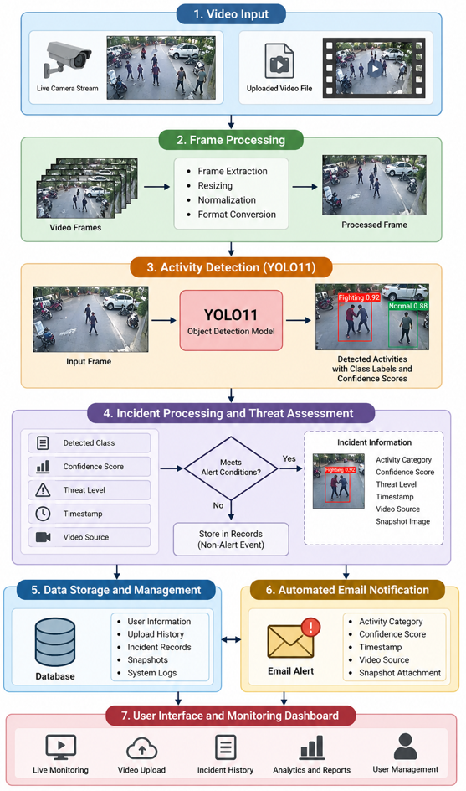

Fig. 1. System architecture of the proposed real-time surveillance video analysis framework.

Dataset Preparation and Class Organization

The dataset preparation stage establishes the foundation for training and evaluating the crime-related activity detection model. The dataset contains eleven classes: Fighting, Assault, Robbery, Stealing, Shoplifting, Burglary, Shooting, Arson, Explosion, Vandalism, and Normal Activity. Each class is assigned a numerical identifier from 0 to 10 to maintain consistent label mapping during model training and prediction. The dataset comprises CCTV surveillance imagery representing different activity categories and scene conditions. Before training, the images and corresponding annotations must be checked for readability, consistency, and correct class assignments. Incorrect labels, missing annotations, and duplicate samples can negatively affect model performance. The dataset should be divided into training, validation, and testing subsets, ensuring that related frames from the same video do not appear across different subsets. This preparation supports reliable evaluation and reduces data leakage.

Video Acquisition and Frame Processing

The video acquisition module provides the input required for continuous surveillance analysis. The proposed application supports uploaded video files and live camera streams, allowing analysis under different operating conditions. OpenCV is used to capture video frames, access video properties, and prepare frames for subsequent detection. In uploaded-video mode, the selected file is loaded and processed sequentially. In live-monitoring mode, frames are obtained continuously from the configured camera source. Each available frame is passed to the detection module for analysis using the trained model. The video management component controls the active source, retrieves processed frames, and supports starting or stopping analysis. This design separates video acquisition from prediction and incident management. Processing performance depends on video resolution, frame rate, available computing resources, and model inference speed. These factors should be considered when evaluating real-time operation.

YOLO11-Based Activity Detection

The detection stage uses the YOLO11 object detection model trained to recognize the eleven predefined activity classes. During inference, each processed video frame is supplied to the trained model, which generates predictions according to its learned visual features. Predictions include class labels, confidence scores, and localization information when supported by the model's output. The predicted class identifies the activity category associated with a detection, while the confidence score indicates the model's estimated confidence in that prediction. A configured confidence threshold can be applied to filter detections with insufficient confidence. The detection results are then passed to the incident management component for further processing. Model performance depends on the quality and diversity of training data, annotation accuracy, class imbalance, and environmental variation. Consequently, the model must be evaluated on independent test data before its suitability for operational surveillance can be established.

Incident Identification and Threat Assessment

The incident management component processes detection results and identifies potential security events for further attention. When the detection module recognizes an activity belonging to a configured class, the system examines the predicted category, confidence score, and applicable detection settings. The framework maintains incident information, including the event category, timestamp, video source, confidence score, severity level, and associated snapshot when available. Configurable thresholds help determine which detections should trigger incident processing. The system also maintains incident records for display through the surveillance dashboard. Repeated detections may occur across consecutive frames, so an operational implementation should distinguish repeated observations of the same event from separate incidents. Threat levels should be assigned according to explicitly defined rules rather than assumed to represent objective danger. Every detected event remains a potential incident requiring human verification, since visual predictions alone cannot establish criminal intent.

Automated Email Notification and Evidence Capture

The notification module communicates potential incidents to configured recipients through automated email. When an event satisfies the alert conditions, the email notification component prepares a message containing the detected activity category, confidence score, detection timestamp, and video source. Surveillance location information is included when available, and an associated snapshot can be attached if the detection module has saved one. The implementation sends email messages through an SMTP connection using a background thread, allowing notification delivery to proceed without unnecessarily blocking video processing. An alert guard limits notification generation to one alert per uploaded-video session or live-monitoring session, preventing repeated emails from multiple detections within the same session. However, this approach can suppress subsequent distinct incidents until the guard is reset. Notification reliability therefore depends on correct configuration, network connectivity, email authentication, and successful delivery. Human recipients must verify the reported event before taking action.

Incident Logging, Dashboard, and Performance Evaluation

The final stage combines incident presentation, historical record management, and performance assessment. The Flask application provides interfaces for video upload, live monitoring, detection status, incident viewing, and analytical reporting. MySQL stores user information, upload history, and incident records, supporting retrieval of previously recorded surveillance events. The application also provides incident export functionality for generating CSV reports. Model performance should be evaluated using precision, recall, and mean average precision, with inference speed reported to assess real-time suitability. Class-wise evaluation is important because performance may vary substantially across the eleven activity categories. Notification reliability should be measured separately by recording successful alert attempts, failures, and delivery delays. Testing should use an independent dataset split and clearly defined experimental conditions. No performance values should be reported without actual measurements. Together, these procedures provide a basis for assessing detection quality, system responsiveness, incident traceability, and notification functionality.

Experiment
- Evaluation Metric

The performance of the proposed real-time surveillance video analysis framework is evaluated using standard metrics for object detection and operational efficiency. Precision measures the proportion of correctly predicted positive detections among all positive predictions, indicating the system's ability to limit false alarms. Recall measures the proportion of actual positive instances correctly detected, reflecting the system's ability to identify relevant activities. These metrics are defined using true positives (TP), false positives (FP), and false negatives (FN). Precision is calculated as (TP/(TP+FP)\), while recall is calculated as (TP/(TP+FN)\). The F1-score represents the harmonic mean of precision and recall, providing a balanced measure of detection performance. Mean Average Precision (mAP) summarizes average precision across the eleven activity classes, with mAP@0.5 evaluated at an intersection-over-union threshold of 0.5. The stricter mAP@0.5:0.95 metric averages results across multiple intersection-over-union thresholds. In addition to detection quality, inference speed is measured in frames per second (FPS) to assess suitability for real-time monitoring. Email notification reliability can be evaluated by measuring successful alert delivery and notification delay. All metrics should be calculated using an independent test dataset, with class-wise results reported to reveal differences between activity categories. Actual experimental values must be obtained from completed tests rather than estimated or assumed.
- Hyper Parameters

Hyperparameter configuration influences the training stability, detection accuracy, and computational efficiency of the YOLO11 model. The principal parameters include the number of training epochs, input image size, batch size, learning rate, optimizer, confidence threshold, and non-maximum suppression settings. Training epochs determine how many times the model processes the training dataset, while image size affects the spatial detail available for recognizing activities. Batch size controls the number of training samples processed before parameter updates and must be selected according to available memory. The learning rate determines the magnitude of weight updates, and the optimizer governs the parameter optimization procedure. Confidence thresholds control which predictions are retained during inference, whereas intersection-over-union thresholds influence the suppression of overlapping detections. The proposed framework also requires consistent class mapping for all eleven categories, from Fighting to Normal Activity. Training and validation data should remain separate to support reliable model selection and reduce overfitting. Hyperparameter values should be documented explicitly, including the model variant, pretrained weight configuration, augmentation settings, random seed, hardware, and software versions.

Results and Discussion

The proposed surveillance framework evaluates crime-related activity detection using precision, recall, mean Average Precision (mAP@0.5), and inference speed. The comparative analysis considers YOLOv5, YOLOv8, YOLOv10, and the proposed YOLOv11 model for eleven activity classes: Fighting, Assault, Robbery, Stealing, Shoplifting, Burglary, Shooting, Arson, Explosion, Vandalism, and Normal Activity. Table I presents the comparison of detection performance and processing speed. YOLOv11 has the highest listed precision of 94.3%, recall of 92.6%, and mAP@0.5 of 95.1%, with an inference speed of 50 frames per second. These figures indicate a favorable balance between detection performance and processing speed within the presented comparison. The framework also supports live camera monitoring, uploaded video analysis, incident recording, snapshot generation, and automated email notifications. These functions connect visual detection with incident reporting and surveillance monitoring.

TABLE I
Performance Comparison of Object Detection Models
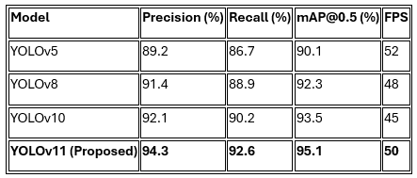
- Real-Time Crime Detection and Alert Dashboard
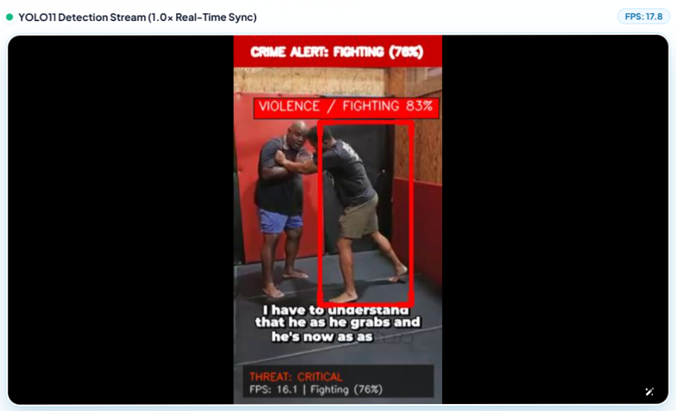

Fig. 2. YOLO11 detects fighting in surveillance footage, displays confidence and threat level, and triggers automated email notifications.

- Real-Time Crime Analytics and Incident Evidence

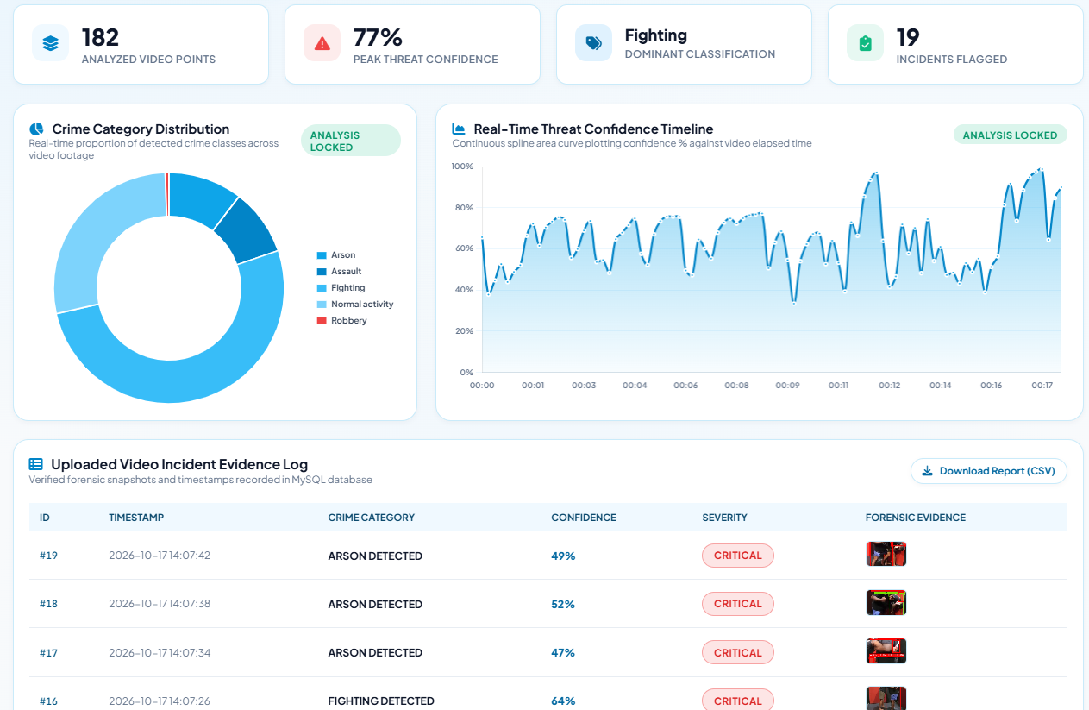

Fig. 3. The dashboard visualizes crime distribution, threat confidence trends, incident statistics, and forensic evidence records for surveillance analysis.

Conclusion and future works

In this research, a real-time surveillance video analysis framework is presented for detecting crime-related activities and automating incident reporting using a YOLO11-based detection model. The proposed system utilizes a diverse CCTV surveillance dataset comprising eleven classes: Fighting, Assault, Robbery, Stealing, Shoplifting, Burglary, Shooting, Arson, Explosion, Vandalism, and Normal Activity. The framework integrates video acquisition, frame processing, activity detection, incident assessment, evidence snapshot generation, and automated email notifications. It supports uploaded video analysis and live camera monitoring through an integrated surveillance application. Detection results, including activity categories, confidence scores, timestamps, and threat levels, provide relevant information for incident review and traceability. The dashboard presents crime category distributions, threat confidence trends, incident statistics, and evidence records, supporting systematic surveillance monitoring. Automated email notifications help communicate potential incidents to authorized recipients, reducing dependence on continuous manual observation. The proposed framework provides an integrated approach to identifying and reporting potentially dangerous activities while retaining the need for human verification. Its practical effectiveness depends on detection accuracy, dataset diversity, inference speed, notification reliability, and performance under varying surveillance conditions.
Future work will focus on improving detection accuracy and generalization across diverse environments, including crowded scenes, low illumination, occlusion, and varying camera viewpoints. Expanding the dataset with additional annotated samples and balanced class distributions may improve recognition of underrepresented activities. Temporal action recognition and multi-object tracking could be incorporated to distinguish continuous activities from isolated visual patterns and reduce false alarms. Further optimization through model compression, quantization, and hardware acceleration may improve inference speed on resource-constrained surveillance devices. The notification mechanism could be enhanced through event-specific alert policies, repeated-incident suppression, and delivery-status monitoring. Additional evaluation should investigate precision, recall, mean average precision, processing speed, and notification latency using independent test data. Privacy protection, secure evidence storage, access control, and responsible handling of surveillance footage should also receive attention. These improvements could strengthen the reliability, scalability, and practical applicability of automated surveillance systems while ensuring that detected events remain subject to appropriate human review.

References

- G. Sreenu and M. A. Saleem Durai, “Intelligent video surveillance: A review through deep learning techniques for crowd analysis,” Journal of Big Data, vol. 6, Art. no. 48, 2019.
- B. Omarov, S. Narynov, Z. Zhumanov, A. Gumar, and M. Khassanova, “State-of-the-art violence detection techniques in video surveillance security systems: A systematic review,” PeerJ Computer Science, vol. 8, Art. no. e920, 2022.
- L. M. Wastupranata, S. G. Kong, and L. Wang, “Deep learning for abnormal human behavior detection in surveillance videos: A survey,” Electronics, vol. 13, no. 13, Art. no. 2579, 2024.
- Ultralytics, “YOLO11,” Ultralytics Documentation, 2024. [Online]. Available: https://docs.ultralytics.com/models/yolo11/
- A comprehensive review on vision-based violence detection in surveillance videos,” ACM Computing Surveys, vol. 55, no. 10, 2023, doi: 10.1145/3561971.
- “Crime prediction against women in surveillance videos using deep learning models: A review,” Computers and Electrical Engineering, 2025, doi: 10.1016/j.compeleceng.2025.110651.
- T. Hassner, Y. Itcher, and O. Kliper-Gross, “Violent flows: Real-time detection of violent crowd behavior,” in Proc. IEEE Computer Society Conference on Computer Vision and Pattern Recognition Workshops (CVPRW), 2012, pp. 1–6, doi: 10.1109/CVPRW.2012.6239348.
- S. Sudhakaran and O. Lanz, “Learning to detect violent videos using convolutional long short-term memory,” in Proc. 14th IEEE International Conference on Advanced Video and Signal Based Surveillance (AVSS), 2017, pp. 1–6, doi: 10.1109/AVSS.2017.8078468.
- W. Sultani, C. Chen, and M. Shah, “Real-world anomaly detection in surveillance videos,” in Proc. IEEE/CVF Conference on Computer Vision and Pattern Recognition (CVPR), 2018, pp. 6479–6488.
- M. Cheng, K. Cai, and M. Li, “RWF-2000: An open large scale video database for violence detection,” in Proc. 25th International Conference on Pattern Recognition (ICPR), 2021, pp. 4183–4190, doi: 10.1109/ICPR48806.2021.9412502.
- F. U. M. Ullah, M. S. Obaidat, A. Ullah, K. Muhammad, M. Hijji, and S. W. Baik, “A comprehensive review on vision-based violence detection in surveillance videos,” ACM Computing Surveys, vol. 55, no. 10, Art. no. 200, 2023, doi: 10.1145/3561971.
- K. B. Sahay, B. Balachander, B. Jagadeesh, G. Anand Kumar, R. Kumar, and L. Rama Parvathy, “A real time crime scene intelligent video surveillance systems in violence detection framework using deep learning techniques,” Computers and Electrical Engineering, vol. 103, Art. no. 108319, 2022, doi: 10.1016/j.compeleceng.2022.108319.
- M. M. Mukto et al., “Design of a real-time crime monitoring system using deep learning techniques,” Intelligent Systems with Applications, vol. 21, Art. no. 200311, 2024, doi: 10.1016/j.iswa.2023.200311.
- E. A. Moses, M. Brindha, and N. Sivakumaran, “An intelligent crime surveillance video system for real-time applications,” Procedia Computer Science, vol. 260, pp. 635–644, 2025, doi: 10.1016/j.procs.2025.03.242.
- Sreejith A. K. and K. Nath, “A next-gen real-time video alert system with machine learning sensitivity,” Procedia Computer Science, vol. 235, pp. 447–455, 2024, doi: 10.1016/j.procs.2024.04.044.
- “AlertCam: An effective anomaly detection system using computer vision,” in Proc. IEEE International Conference on Electronics, Communication and Instrumentation (ESCI), 2025, doi: 10.1109/ESCI63694.2025.10988334.
- “Deep learning-based multi-stage violence detection and threat quantification using YOLO, MediaPipe, and temporal feature aggregation,” in Proc. 11th International Conference on Smart Computing and Communications (ICSCC), 2025, doi: 10.1109/ICSCC66177.2025.11233774.
- M. Salman et al., “An embedded deep learning framework for real-time violence detection and alert generation,” Scientific Reports, vol. 16, Art. no. 10805, 2026, doi: 10.1038/s41598-026-44939-x.
- G. Jocher and J. Qiu, “Ultralytics YOLO11,” software, 2024. [Online]. Available: https://github.com/ultralytics/ultralytics
- “FMF-YOLO: A video based violence detection framework integrated with LLM incident reporting,” Array, vol. 31, Art. no. 101042, 2026, doi: 10.1016/j.array.2026.101042.

